

**Batch: A-3 Roll No.: 16010122104**

**Experiment No. 6**

**Grade: AA / AB / BB / BC / CC / CD /DD**

**Signature of the Staff In-charge with date**

|  |
| --- |
| **Title:** Implement contrast stretching of a digital image. |

**Objective:** To learn & understand contrast stretching.

**Expected Outcome of Experiment:**

|  |  |
| --- | --- |
| **CO** | **Outcome** |
| **CO4** | Design & implement algorithms for digital image enhancement, segmentation & restoration. |

**Books/ Journals/ Websites referred:**

1. http://www.mathworks.com/support/
2. www.math.mtu.edu/~msgocken/intro/intro.html.
3. R. C.Gonsales R.E.Woods, “Digital Image Processing”, Second edition, Pearson Education
4. S.Jayaraman, S Esakkirajan, T Veerakumar “Digital Image Processing “Mc Graw Hill.
5. S.Sridhar,”Digital Image processing”, oxford university press, 1st edition."

**Pre Lab/ Prior Concepts:**

Contrast stretching (often called normalization) is a simple image enhancement technique that attempts to improve the contrast in an image by `stretching' the range of intensity values it contains to span a desired range of values, *e.g.* the the full range of pixel values that the image type concerned allows. It differs from the more sophisticated histogram equalization in that it can only apply a *linear* scaling function to the image pixel values. As a result the `enhancement' is less harsh.

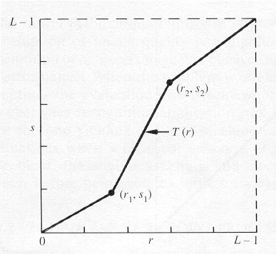

The locations of (r1,s1) and (r2,s2) control the shape of the transformation function.

* If r1= s1 and r2= s2 the transformation is a linear function and produces no changes.
* If r1=r2, s1=0 and s2=L-1, the transformation becomes a thresholding function that creates a binary image.
* Intermediate values of (r1,s1) and (r2,s2) produce various degrees of spread in the gray levels of the output image, thus affecting its contrast.

Generally, r1≤r2 and s1≤s2 is assumed.

**Implementation steps with screenshots:**

A = imread('C:\Users\kashi\OneDrive\Desktop\KJSCE\BTech\SEM VI\DSIP\LAB\parrot.bmp');

if size(A, 3) == 3

A = rgb2gray(A);

end

A = double(A);

r1 = input('Enter the value for r1 (lower input range): ');

s1 = input('Enter the value for s1 (lower output range): ');

r2 = input('Enter the value for r2 (upper input range): ');

s2 = input('Enter the value for s2 (upper output range): ');

L = 256;

B = zeros(size(A), 'uint8');

% Contrast stretching parameters

alpha = s1 / r1;

beta = (s2 - s1) / (r2 - r1);

gamma = ((L - 1) - s2) / ((L - 1) - r2);

for i = 1:size(A, 1)

for j = 1:size(A, 2)

r = A(i, j);

if r < r1

B(i, j) = alpha * r;

elseif r1 <= r && r <= r2

B(i, j) = s1 + beta * (r - r1);

else

B(i, j) = s2 + gamma * (r - r2);

end

end

end

figure;

%Original Image

subplot(1, 2, 1);

imshow(uint8(A));

title('Original Image');

%Contrast Streched image

subplot(1, 2, 2);

imshow(B);

title(sprintf('Contrast Stretched\n(α=%.2f, β=%.2f, γ=%.2f)\n (r1=%.2f,r2=%.2f,s1=%.2f,s2=%.2f)', alpha, beta, gamma, r1,r2,s1,s2));

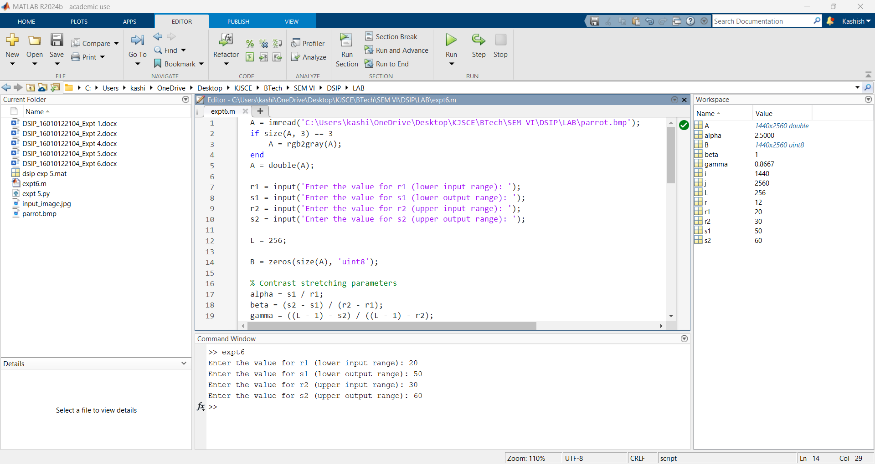

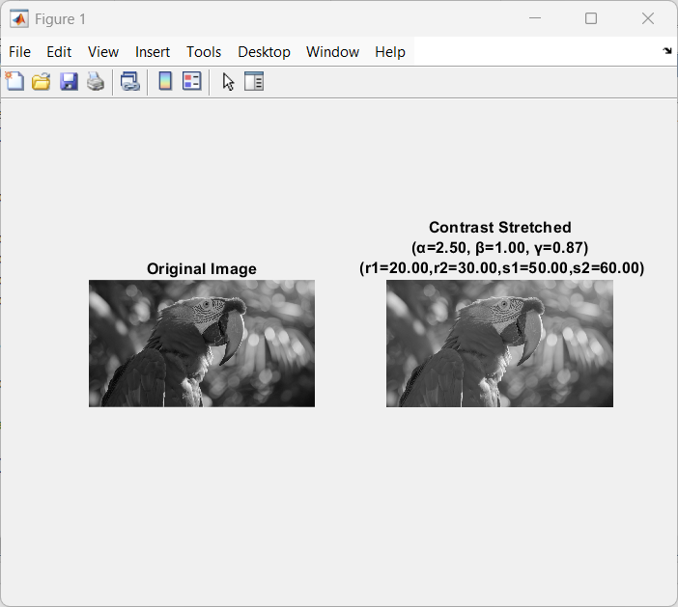

**Conclusion:-**

Implemented contrast stretching on a image of a parrot.

**Date: 11/03/2025 Signature of faculty in-charge**

**Post Lab Descriptive Questions**

1. Thresholding function in contrast stretching creates
2. binary image
3. high quality image
4. enhanced image
5. low quality image

**Ans: a) binary image**

**Explanation: When a thresholding function is applied in contrast stretching, it typically creates a binary image by setting all pixel values above a certain threshold to white and those below to black.**

1. When is the contrast stretching transformation a linear function, for r and s as gray-value of image before and after processing respectively?

a) r1 = s1 and r2 = s2

b) r1 = r2, s1 = 0 and s2 = L – 1, L is the max gray value allowed

c) r1 = 1 and r2 = 0

d) None of the mentioned

**Ans: a) r1 = s1 and r2 = s2**

**Explanation: The contrast stretching transformation is a linear function when the input and output gray levels at the two points are equal, i.e., r1 = s1 and r2 = s2.**

3. Which gray-level transformation increase the dynamic range of gray-level in the image?

a) Power-law transformations

b) Negative transformations

c) Contrast stretching

d) None of the mentioned

**Ans: c) Contrast stretching**

**Explanation: Contrast stretching increases the dynamic range of gray levels by mapping the original range of pixel values to the full range of possible values, enhancing the contrast and visibility of details in the image.**

4. When is the contrast stretching transformation a thresholding function, for r and s as gray-value of image before and after processing respectively?

a) r1 = s1 and r2 = s2

b) r1 = r2, s1 = 0 and s2 = L – 1, L is the max gray value allowed

c) r1 = 1 and r2 = 0

d) None of the mentioned

**Ans: b) r1 = r2, s1 = 0 and s2 = L – 1, L is the max gray value allowed**

**Explanation: The contrast stretching transformation becomes a thresholding function when r1 = r2 (the same threshold value), s1 = 0 (pixels below threshold set to black), and s2 = L – 1 (pixels above threshold set to white), effectively creating a binary image.**

5. What condition prevents the intensity artifacts to be created while processing with contrast stretching, if r and s are gray-values of image before and after processing respectively?

a) r1 = s1 and r2 = s2

b) r1 = r2, s1 = 0 and s2 = L – 1, L is the max gray value allowed

c) r1 = 1 and r2 = 0

d) r1 ≤ r2 and s1 ≤ s2

**Ans: d) r1 ≤ r2 and s1 ≤ s2**

**Explanation: To prevent intensity artifacts, the transformation must be monotonically increasing, meaning that r1 ≤ r2 and s1 ≤ s2. This ensures that the output gray levels are always greater than or equal to the input gray levels, maintaining a consistent and artifact-free transformation.**